TJ DCR Project -Bandpass filter
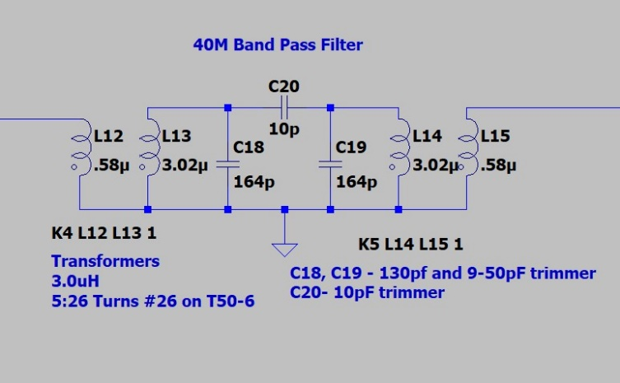

- Wind the toroids – Magnet wire - 26 turns of wire, leave about am inch, each time through the core is 1 turn.  - Hookup wire – 5 turns  - Scrape or burn the insulation off the magnet wire and tin the leads  - You can solder the ground leads together at this point | 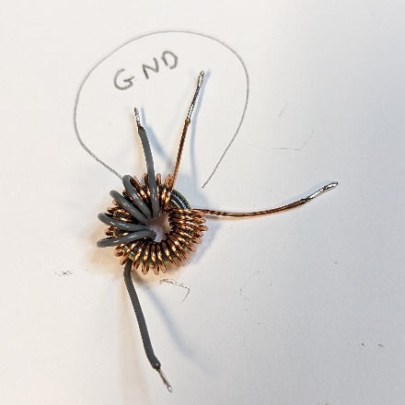
- Check the inductance – squeeze or spread the turns to get close to 3.02uH | 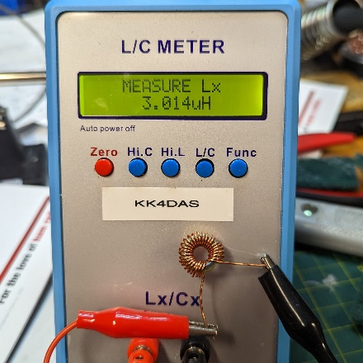
- Layout the board. Just 4 pads  - Solder in the trimmers | 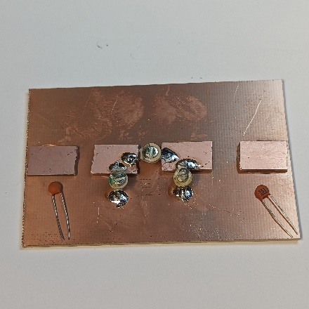
- Carefully bend the feet of the trimmers | 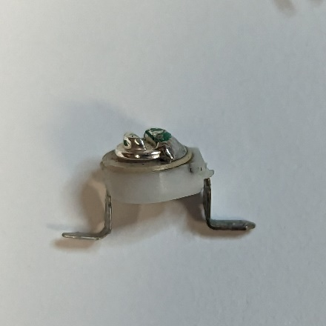
- Solder in the fixed capacitors | 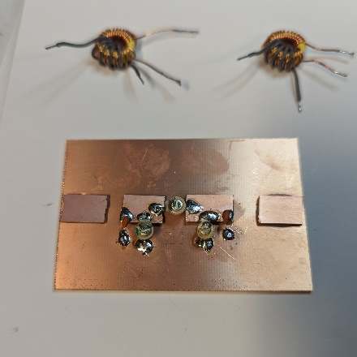
- Solder in the transformers – ground leads first | 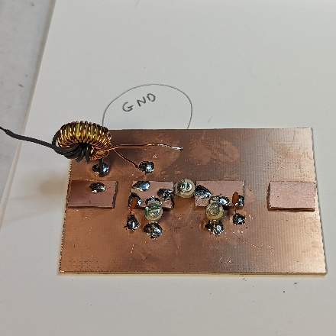
- Hookup wire goes to the input and output pads, magnet wire goes to the pad with the capacitors | 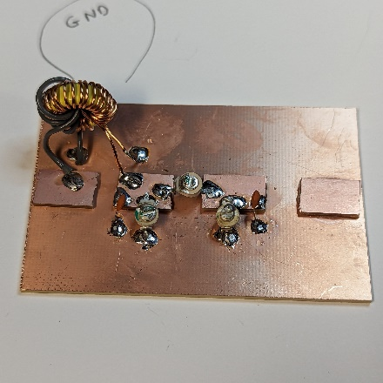
- Completed filter | 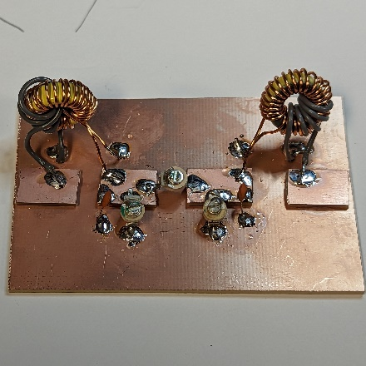
- Test and trim using the Nano VNA | 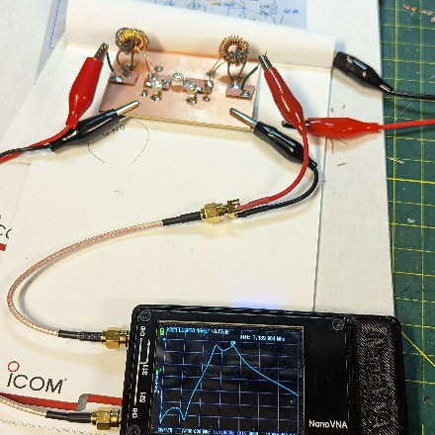
- Done! | 